5 marker questions

1. A man desired to get into his work building, however he had forgotten his code.   
   However, he did recollect five pieces of information  
   -> Sum of 5th number and 3rd number is 14.  
   -> Difference of 4th and 2nd number is 1.  
   -> The 1st number is one less than twice the 2nd number.  
   ->The 2nd number and the 3rd number equals 10.  
   ->The sum of all digits is 30.

Ans: 74658

1. You are at Burj Khalifa, from that point a building A is at N60E another building B is at S45E and building C is at S40W, Now a building D is at 80 degree anticlockwise to A, 120 degrees clockwise to C and 205 degrees clockwise to B. Find the quarter circle bearing of D.

Consider your location as the origin. (Answer is the following format eg : S79E)

ANSWER N20W/W70N

1. You are at Ferrari world Abu Dhabi and you notice an 800 kg roller-coaster is released from rest at Point A of the track shown in the figure. Assume there is no friction or air resistance between Points A and C. How fast is the roller-coaster moving at Point B? What average force is required to bring the roller-coaster to a stop at Point D if the brakes are applied at Point C?

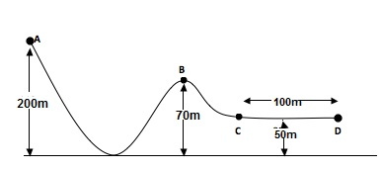

ANSWER: 12000

1. BC is a cantilever bridge of span 8.279 m. Find the reaction force Ra if along with the force shown figure, a **UDL of 30 N/m** is there throughout span. Find Ra

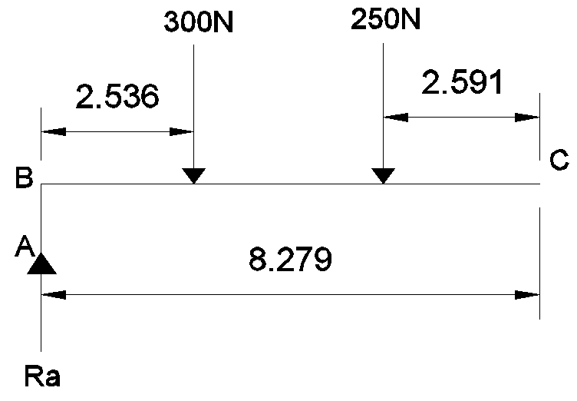

ANSWER: 550KN

1. You go on a surveying project along with a few sight engineers at KL tower, and

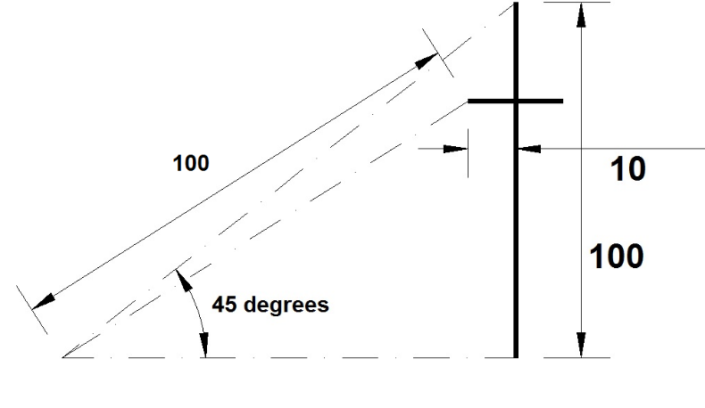You are sighting the KL tower through a theodolite and found it makes at the angle of the top of the tower to be 45 degrees. Following figure is formed as a result of it, find the height of the observation deck, which here has been shown as a straight line with a halfway distance of 10 units.

ANSWER: 25 cm

1. Given F=100N and Mass = 10 kg, assuming g=10 m/s2 find the acceleration in M.

ANSWER:

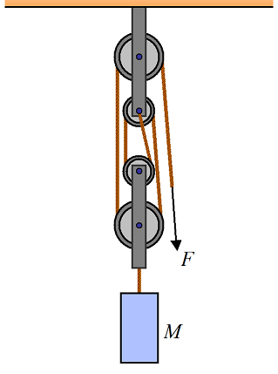

Answer: 30 m/s2

1. While you were in Brazil, the government made a major change by shifting the Brasillia time zone UTC-3 to a new location 9 degrees westwards. If the time before this change was 10:45, what is the time now after the shifting of brasillia time zone? (Answer in the format HH:MM)

ANSWER: 10:09

1. A fully loaded Boeing aircraft has a mass of 3.3x 10^5 kg. Its total wing area is 500 m2. It is in level flight with a speed of 960 kmph. Estimate the percentage increase in the speed of the air on the upper surface of the wing relative to the lower surface. The density of air is 1.2 kg/m3

ANSWER: 8%

1. A man desired to get into his work building, however he had forgotten his code.   
   However, he did recollect five pieces of information  
   -> Sum of 5th number and 3rd number is 14.  
   -> Difference of 4th and 2nd number is 1.  
   -> The 1st number is one less than twice the 2nd number.  
   ->The 2nd number and the 3rd number equals 10.  
   ->The sum of all digits is 30.

A: 74658

1. In a certain code language, ‘*kew xas huma deko*’ means ‘*she is eating apples*’; ‘*kew tepo qua*’ means  
       ‘*she sells toys*’ and ‘*sul lim deko*’ means ‘*I like apples*’. Which word in that language means ‘*she*’ and  
       ‘*apples*’?

 a. xas & deko

 b. xas & kew

 c. kew & deko

 d. kew & xas

ANSWER: C

1. The figure given on the left hand side in the following question is folded to form a box. Choose from the alternatives (1), (2), (3) and (4) the boxes that is similar to the box formed.

|  |  |
| --- | --- |
|  | http://www.indiabix.com/_files/images/verbal-reasoning/dice/4-13-3-5.png |
| |  |  | | --- | --- | | [A.](javascript:%20void%200;) | 1 and 2 only | | [B.](javascript:%20void%200;) | 2 and 4 only | | [C.](javascript:%20void%200;) | 2 and 3 only | | [D.](javascript:%20void%200;) | 1 and 4 only |   Answer: Option C |

1. Find the values of RA and RB (Round off your answer to the nearest whole number).

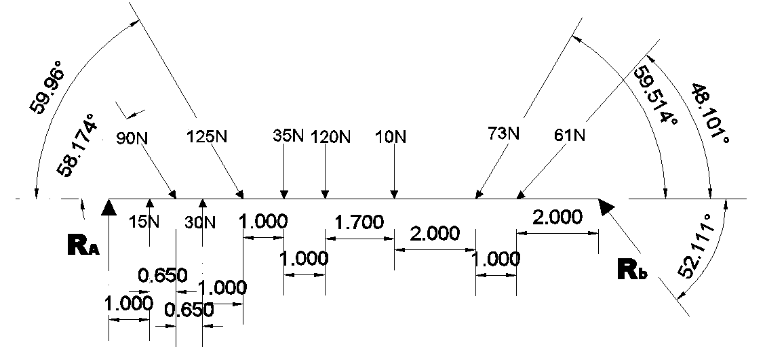

ANSWER: . RA= 372 , RB= 53

1. A rocket is fired vertically from the surface of mars with a speed of 2km/s. If 20% of its initial energy is lost due to martian atmosphere resistance, how far will the rocket go from the surface of mars before returning to it? Mass of mars= 6.4x1023 kg, radius of mars= 3395km, G=6.67x10-11Nm2/kg.

ANSWER: 495km

1. A nut comes loose from a bolt on the bottom of an elevator as the elavator is moving up the shaft at 3m/s.The nut strikes the bottom of the shaft in 2 sec.How far from the bottom of the shaft was the elevator when nut falls off?  
   ans. 13.6 m
2. The average of five natural numbers is 150. A particular number among the five exceeds another by 100. The rest three numbers lie between these two numbers and they are equal. How many different values can the largest number among the five take?

1) 59

2) 19

3) 21

4) 42

**Answer: 19**

1. If
2. A + B means A is the mother of B.
3. A - B means A is the sister of B.
4. A * B means A is the father of B.
5. A β B means A is the brother of B.

|  |
| --- |
| Which of the following means that N is the maternal uncle of M? |
| |  |  | | --- | --- | | [A.](javascript:%20void%200;) | N β P - L + E - M | | [B.](javascript:%20void%200;) | N - Y + A β M | | [C.](javascript:%20void%200;) | M - Y * P – N | | [D.](javascript:%20void%200;) | N β C + F * M |   Answer: A |

1. A living specimen in equilibrium with the atmosphere contains one atom of 14C (half life = 5 730 yr) for every 7.7 × 1011 stable carbon atoms. An archeological sample of wood (cellulose, C12H22O11) contains 21.0 mg of carbon. When the sample is placed inside a shielded beta counter with 88.0% counting efficiency, 837 counts are accumulated in one week. Assuming that the cosmic-ray flux and the Earth’s atmosphere have not changed appreciably since the sample was formed, find the age of the sample.

ANSWER: 9.96X 10^3

|  |  |  |  |  |  |  |
| --- | --- | --- | --- | --- | --- | --- |
| . http://www.indiabix.com/_files/images/puzzles/10-12-q-16.png   |  |  |  | | --- | --- | --- | | Answer | : | Jack of SpadeS | |  | : | . | |

1. **I have a few sweets to be distributed. If I keep 2, 3 or 4 in a pack, I am left with one sweet. If I keep 5 in a pack, I am left with none. What is the minimum number of sweets I can have to pack and distribute?**

**ANSWER: 25**

1. In a certain code language : ‘dugo hui mul zo’ stans for ‘work is very hard’ ‘hui dugo ba ki’ for ‘Bingo is very smart’; ‘nano mul dugo’ for ‘cake is hard’; and ‘mul ki gu’ for ‘smart and hard’ Which of the following word stand for Bingo ?  
     
   a) Jalu   
   b) Dugo   
   c) Ki   
   d) Ba

ANSWER: D

1. P, Q, R, S, T, U, V and W are sitting round the circle and are facing the centre:
2. P is second to the right of T who is the neighbour of R and V.
3. S is not the neighbour of P.
4. V is the neighbour of U.
5. Q is not between S and W. W is not between U and S.

|  |  |
| --- | --- |
|  | What is the position of S ? |
| |  |  | | --- | --- | | [A.](javascript:%20void%200;) | Between U and V | | [B.](javascript:%20void%200;) | Second to the right of P | | [C.](javascript:%20void%200;) | To the immediate right of W | | [D.](javascript:%20void%200;) | Data inadequate. |   Answer: Option C |

One of the following numbers can be marked out as the odd one out. Can you find which one?

a) 680986879

b) 716089780

c) 820670987

d) 932967879

ANSWER: c

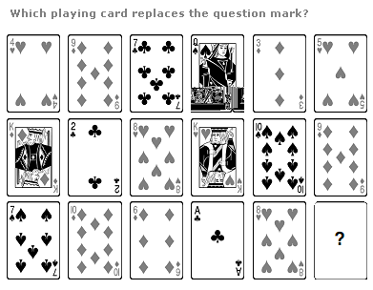

|  |  |
| --- | --- |
|  |  |
|  | |

ANSWER: 7 of spades/ 7 of clubs/ 7 of hearts/ 7 of diamonds

1. Complete the sequence: 5824, 5242, ? , 4247, 3823
2. 4467
3. 4718
4. 4856
5. 5164

ANSWER: B

1. The initial velocity of the particle is u=4**i**+3**j** m/s. It is moving with uniform acceleration a=.4**i**+.3**j** m/s2.which of the following is true  
   a. the magnitude of the velocity after 10 sec is 10m/s  
   b. The velocity vector at time t is given by (4+.4t)**i** +(3+.3t)**j**  
   c. the displacement at time t is (4t+.22)**i** +(3t+.152)**j**  
   d . None of the above

ANSWER: a, b